**CBA Group Assignment**

Please see the Partworth data (regression beta’s) from the Conjoint Analysis on Beer Brands in the file Part-worth Data.xls

**Segmentation**

1. Segment respondents based on the Partworth data (use any unsupervised learning technique).
2. Use the Descriptors in the Demographic data sheet to perform classification (use any supervised learning technique) based on segments obtained in Step 1 and personify /describe each segment.

**Targeting**

1. Calculate the Market Shares of the existing brands in each segment.

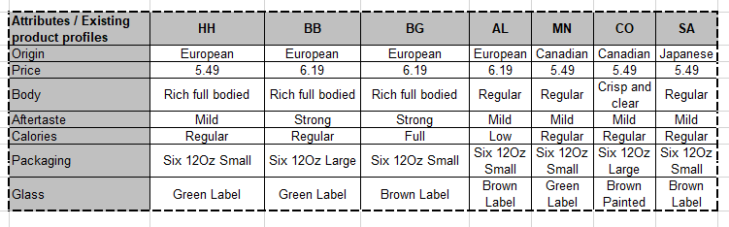

1. If a new brand NB is to be introduced in the market, which segment (question 1&2) will you suggest NB should target, based on your analysis (make appropriate assumptions if required).

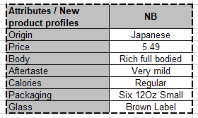

**Appendix**

